ASAS-SN Plugin for VStar

*Description*: This plugin allows you to open text files in the formats of the [All-Sky Automated Survey for Supernovae (ASAS-SN)](http://www.astronomy.ohio-state.edu/asassn/index.shtml).

Data files can be generated using the [ASAS-SN Sky Patrol](https://asas-sn.osu.edu/) website or downloaded from the [ASAS-SN Photometry Database](https://asas-sn.osu.edu/photometry) or [ASAS-SN Variable Stars Database](https://asas-sn.osu.edu/variables). The format of precomputed data files, loaded from *ASAS-SN Photometry* and *ASAS-SN Variable Stars* databases, differs from one generated by the *Sky Patrol*. The plugin loads files of both formats.

# ASAS-SN Sky Patrol data

ASAS-SN Sky Patrol data are computed in real-time using aperture photometry for a point on the celestial sphere for which ASAS-SN images exist. Go to [Sky Patrol website](https://asas-sn.osu.edu/), enter the coordinates of a target and the number of days to go back, then press [Compute]

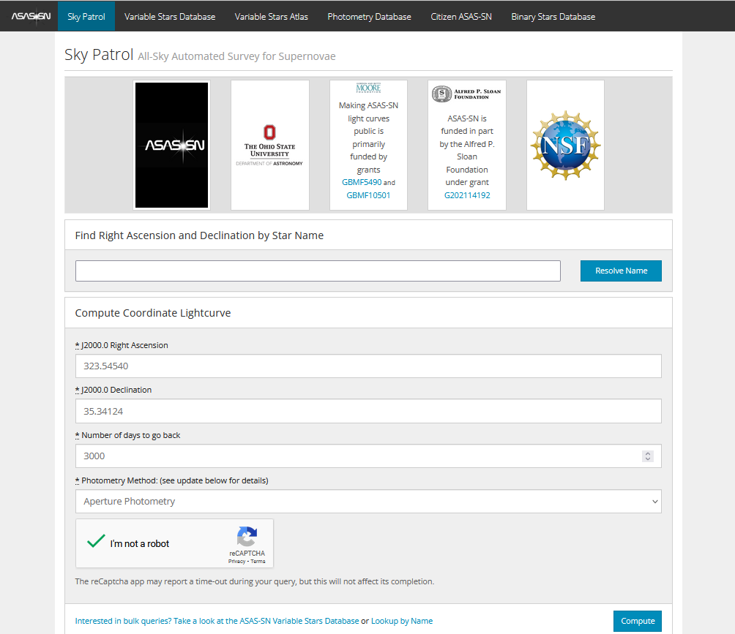

The calculations may take a while. When calculations succeed, you will be redirected to the result page.

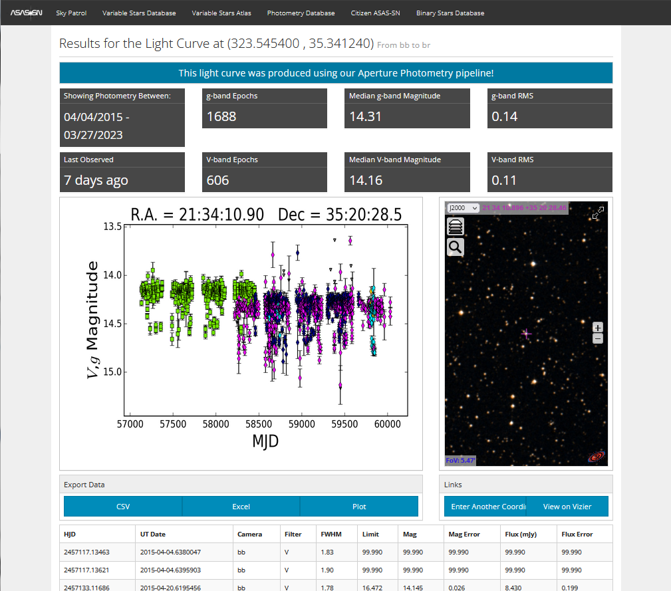

Press the [CSV] button under “Export Data” and save the CSV file to disk. The file contains V and g bands data, as seen from the preview plot.

From VStar, select [New Star from File...] from the [File] menu and then select “ASAS-SN” in the “Source” dropdown list. Go to the location of the saved file and open it.

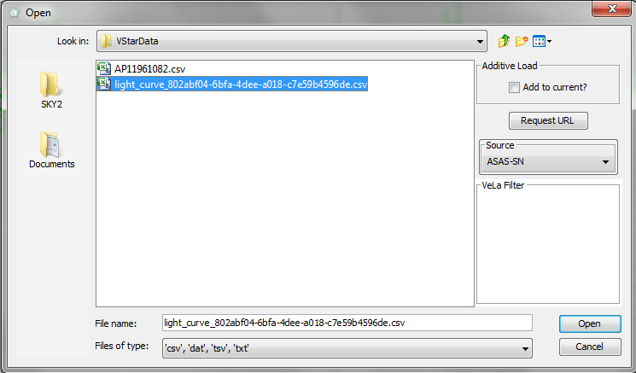

The following dialog will appear:

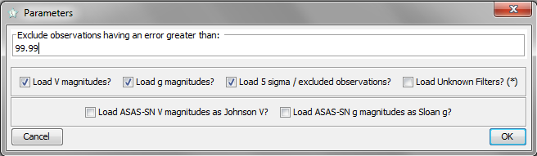

Currently, ASAS-SN light curves can contain data for V and g bands. Some observations in a file can be marked as unreliable (“5 sigma/excluded observations”); they can be excluded by unchecking the corresponding checkbox. A user can limit the maximum allowed uncertainty (“Exclude observations having an error greater than” field).

Select the data you need (let’s assume you have selected data for V band only) and press OK. VStar will show you a light curve:

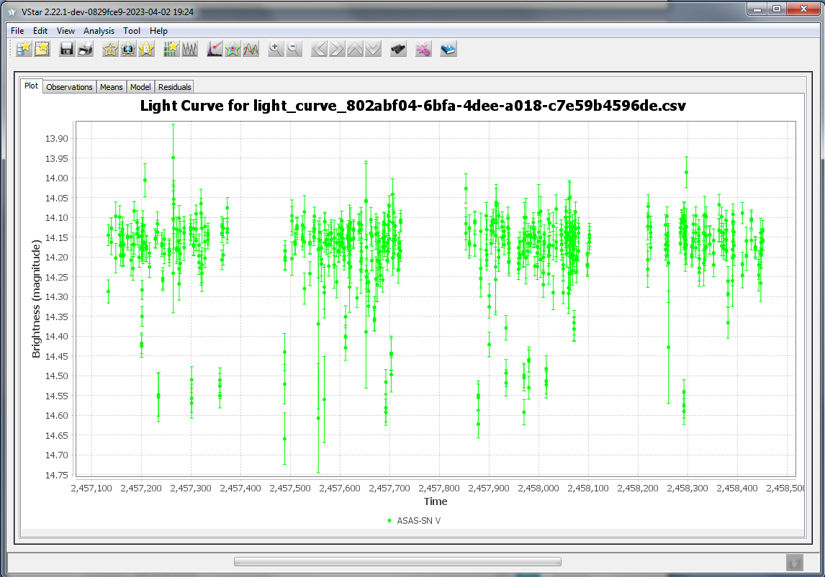

Here is the phase plot for the star (it is an eclipsing binary with a period of 1.095355 days:



# Precomputed ASAS-SN Light Curves

Other sources for ASAS-SN light curves are [ASAS-SN Photometry Database](https://asas-sn.osu.edu/photometry) and [ASAS-SN Variable Stars Database](https://asas-sn.osu.edu/variables). Those databases contain ready-to-use light curves in a format that differs from one produced by Sky Patrol. The plugin loads files of both formats.

To download a light curve, go to one of the databases and enter the coordinates and the search radius (for both databases) or ASAS-SN variable name (for the Variable Star Database). If precomputed curves exist, they will be listed. Do *not* load the data via [Download CSV Dataset] button (the format is currently not supported by the plugin). Instead, click on one of the curves’ IDs.

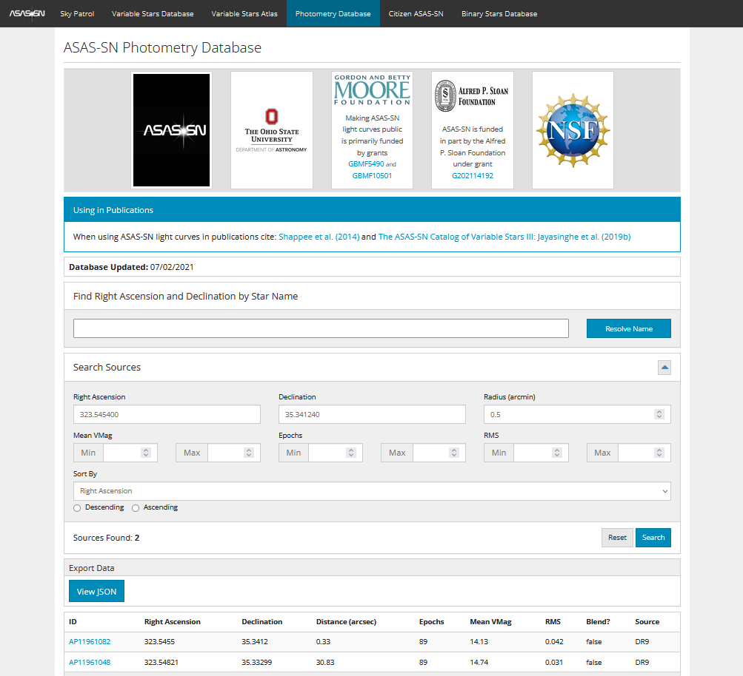

You will see a new window with a preview plot. Click on the [CSV] button under “Export Data” to download a file. This file can be opened by the plugin in the same way as described above.

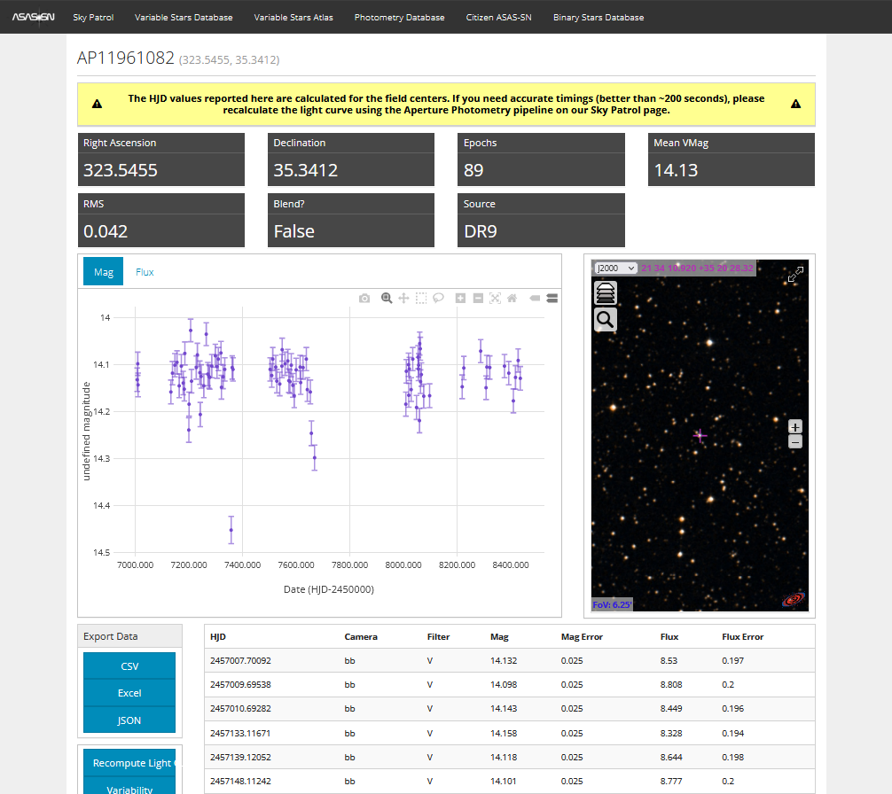

Maksym Pyatnytskyy (PMAK)

Rev C

2023-04-02

**Revision History**

|  |  |  |
| --- | --- | --- |
| Rev | Date | Description |
| C | 2023-04-02 | Updated according to the last plugin’s revision |
| B | 2020-04-26 | Open Dialog image added |
| A | 2020-04-17 | Initial Release |